**Hello October**

This month we will be focusing on the fall season, acorns, leaves, and all the changes in nature. During this time, we will work with students on many different topics:

* How do we know it’s Fall? Students will describe the changes they are witnessing in Nature.
* What is happening to the leaves, the trees, and the temperature?
* What are some of the animals we will see in the Fall season (squirrel, birds, fox, butterflies)?
* Unit study: All about acorns and oak trees.
* We will also be studying all about “Fire Safety.”
* **HAPPY HALLOWEEN Class Party 10/31/2023 at 2:15pm**

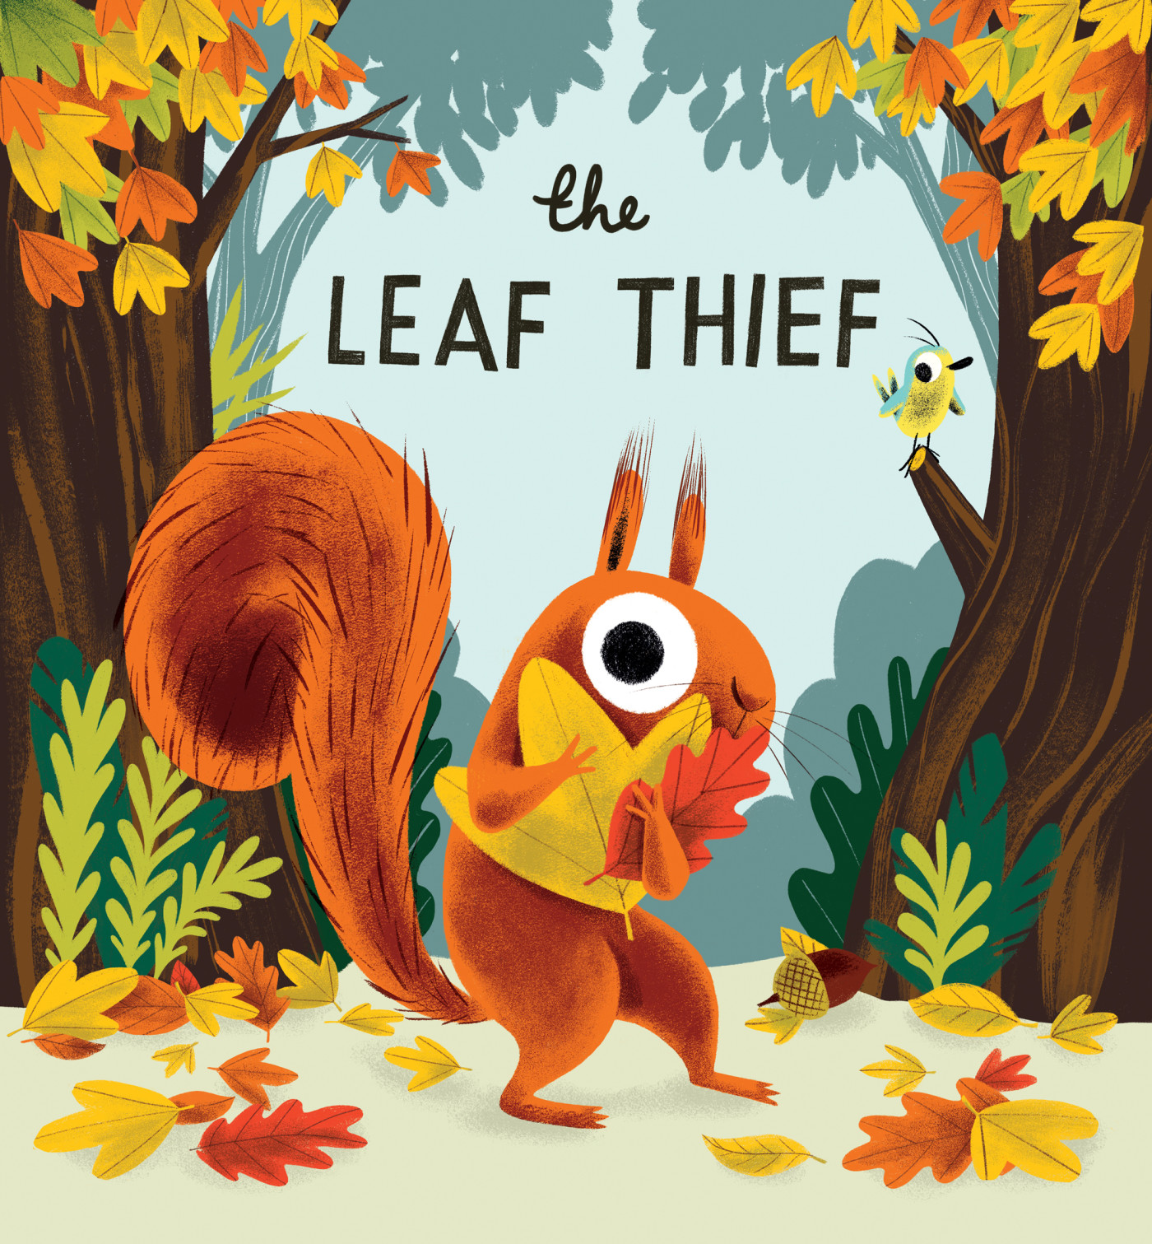

Math- (1st and 2nd) Number bonds 7, 8, 9, 10. Identifying number partners. Students will continue to use IXL and I-Ready to support their learning.

During this month we will continue adding using ten frames.

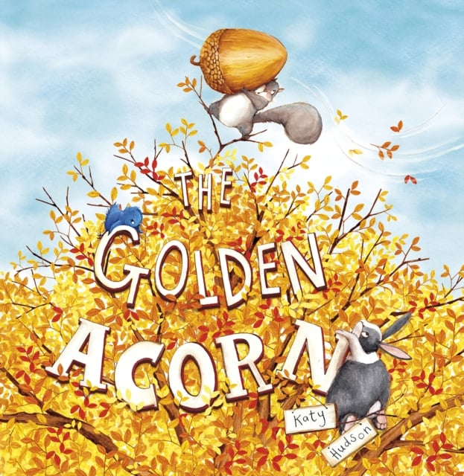

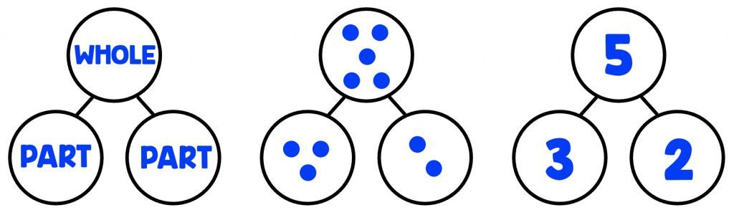

Kindergarten: Count, write and show amounts within 5. Students will use I-Ready and IXL to support their learning.

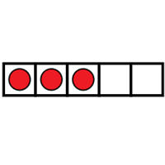

If you need to reach me, please send me a message on ClassDojo. You can also reach me by email at

Agreene@yonkerspublicschools.org

914-562-9551

