School 16
Monthly Writing Topics - April
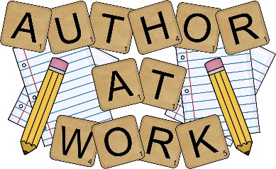
5th grade: Opinion
- E-books vs. Regular Books
- I Phones vs. Androids
- Uniforms vs. Non-uniforms
- Spring
- Earth Day
- Plants / Insects / Life Cycle

School 16 - Genre of the Month
- 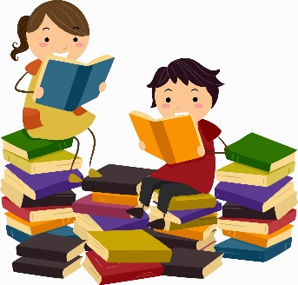
- April: Fantasy

Please read a story from the above genre and then complete a grade specific graphic organizer using details from the book. If you have a graphic organizer that your child is already comfortable with that is like one of these, you may use that instead.

