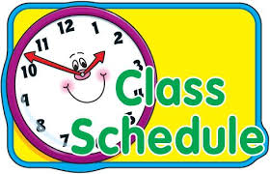

**Mrs. Alvarado’s**

**Daily Schedule**

Student Arrival

Independent Work (name practice, journal, calendar)

Circle Time

Bathroom Break

Pre-K & K ELA Lessons

Independent Work, Montessori Shelf Work

Lunch & Recess

Specials (Art, Gym, Music)

Bathroom Break

Pre-K & K Math Lessons

Independent Work, Montessori Shelf Work

Social Studies/Science

Choice Time

Rest Time/Quiet Time

Pack Up & Dismissal