Mrs. Alvarado’s Specials

**11:25-11:55**



A Day Art

 B Day Music

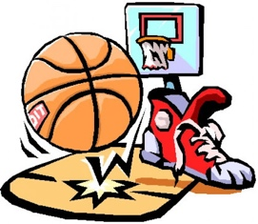

C Day Gym



D Day Art

* Please make sure your child wears sneakers on gym days.