Monthly Writing Topics - June
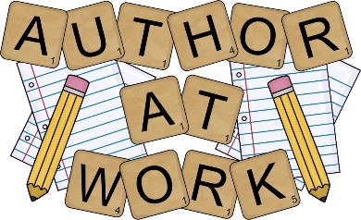
Grades:
K-8 – Personal Narrative:
- Summer Vacation
- School Year Memories
- Overcoming Obstacles
- Favorite Class Trip
- Flag Day
- Distance Learning

Feel Free To Use Any of The Topics Above Or One of Your Choice As Long As It Fits Your Topic

Please send your work to your teacher by Friday, June 19, 2020.

