The Equator and Hemispheres

The Earth is divided into two parts by an imaginary line called the equator. The part of the Earth that is north of the equator is called the 'Vorthern Hemisphere. The part of the Earth that is south of the equator is called the Southern Hemisphere.

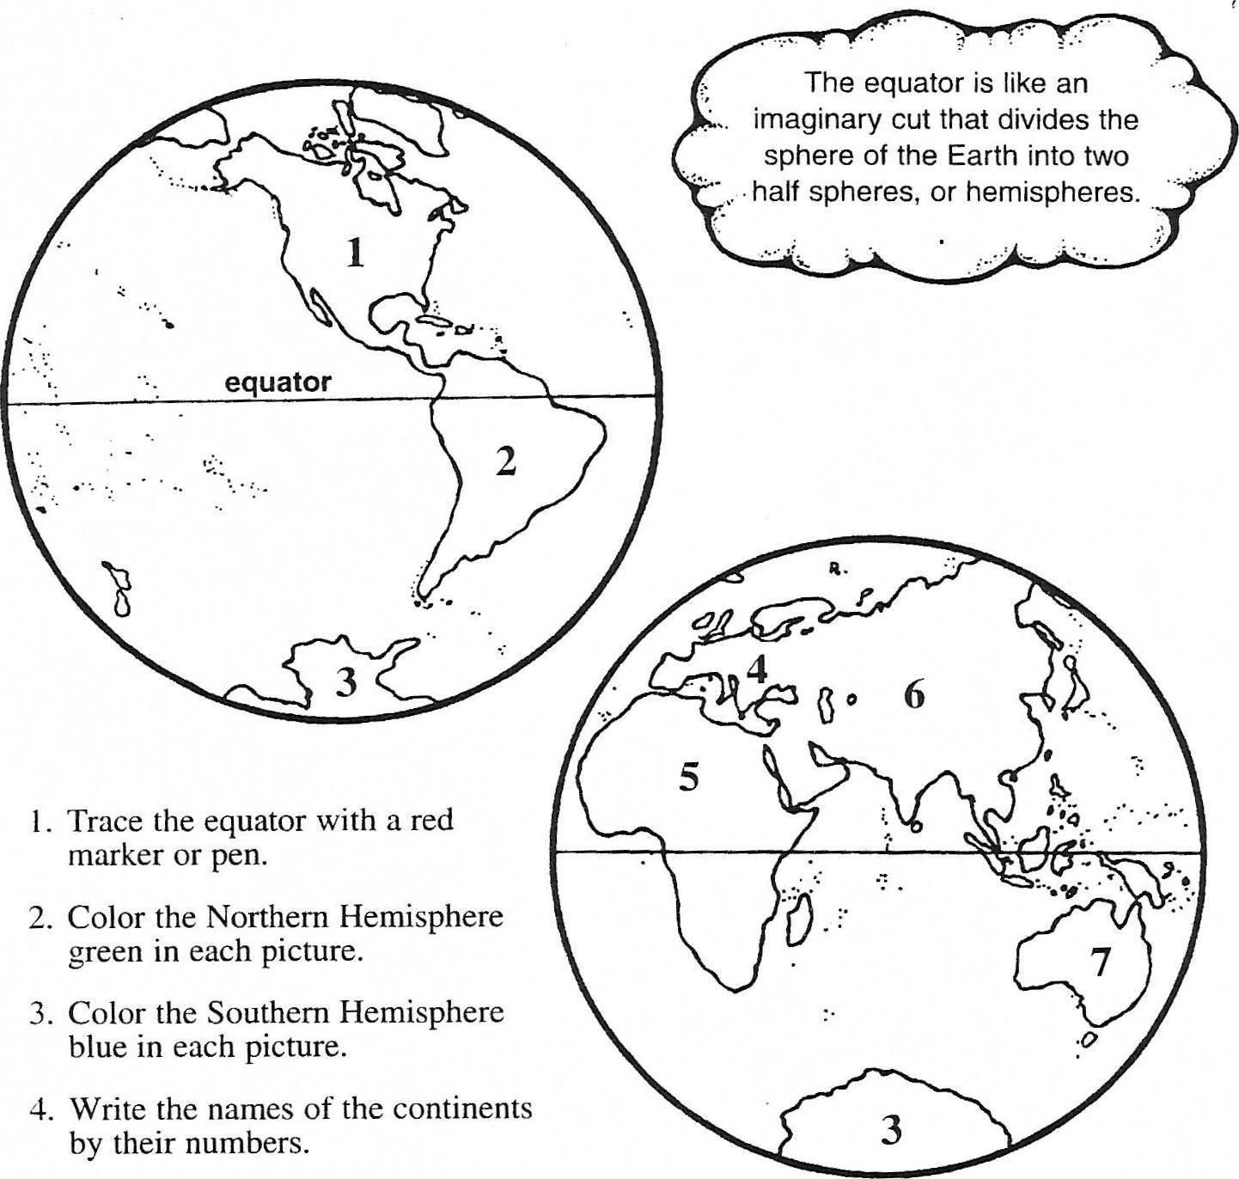l. Trace the equator with a red marker or pen.

1. Color the Northern Hemisphere green in each picture.
2. Color the Southern Hemisphere blue in each picture.
3. Write the names of the continents

2.



3. 4.



5. 6.

und I)iaqrams (O Teacher Created Resources, Inc.