



SURVIVAL GUIDE:

PROJECT

YOUR NAME:_________________________________

**Explore:**

1. Take the survival quiz that is on the FOLLOWING WEBSITE:

[**https://play.howstuffworks.com/quiz/can-you-pass-this-ultimate-survival-quiz**](https://play.howstuffworks.com/quiz/can-you-pass-this-ultimate-survival-quiz)

1. We will discuss the survival quiz in class. How did you do?
2. **Answer the following questions (typed-12 font, times new roman, double spaced…or neatly written)**

* How do you think you would do if you were in Salva or Nya's situation? Explain
* Do you think it is important to have survival skills in the environment you are in? Explain.
* What do you think is the most important thing to know when it comes to survival? Explain.



**Create:**

1. **Create a survival guide using a first-person point of view.  A manual of some sort with your own designs and survival advice based on your research. (A) Include pictures, for example, of the environment you must survive in, tools needed to survive, forces in nature that you may encounter etc. Describe how you survive using whatever is at your disposal(B) CONSIDER CREATING YOUR OWN ORIGINAL ART AND DESIGNS. (C)Manual must have a table of contents. (D)DESIGN A GREAT COVER for YOUR MANUAL for example, “Christian’s Ultimate Survival Guide for the Jungle”…YOU CAN ADD YOUR FACE TO THE COVER (WITH PARENT’S PERMISSION) LET THE COVER FOR YOUR MANUAL STAND OUT!!! (E)YOU CAN DRAW, SKETCH, COLOR, PAINT, SEW, STITCH, VELCROW ETC. (F) LET YOUR SURVIVAL GUIDE REFLECT YOU!!! HAVE FUN WITH YOUR DESIGNS!**

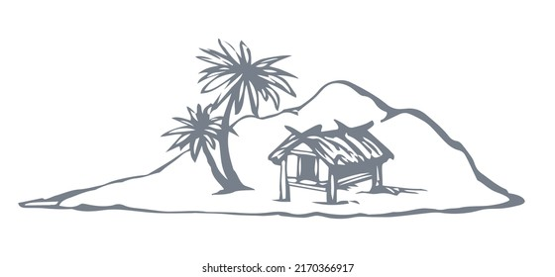

1. **Choose your battle field to survive. Will it be the: (A) Desert? (B)Jungle with every poisonous animal that you can think of? (C)Snow covered geography, with minus degree temperatures ex. Snow covered mountain, waiting to be rescued in 7 days with 3 days’ worth of food? (D)Stranded on a raft in the ocean waiting to be rescued? (E)Island filled with snakes, spiders, wild dogs etc.? (F) A night alone on the streets of a major city like NYC, Chicago etc. (G) Zombie Apocalypse? (H) Living in outer space alone until you’re rescued? (I) A forest fire? (J)Your own choice that’s not listed?**
2. ORGANIZE AND MAKE SURE THAT YOUR FINAL PRODUCT IS NEATLY DONE.

