4th Grade-Module 5-Lesson 10/Mrs. Faour

Objective: Use the area model and division to show the equivalence of two fractions.

Problem –Set page/Watch Video

Fluency Practice /Watch Video

Application Problem/Watch Video

Lesson Requirements:

* Review Class Note/use your math notebook
* Homework page/Submit
* Exit Ticket page/Submit

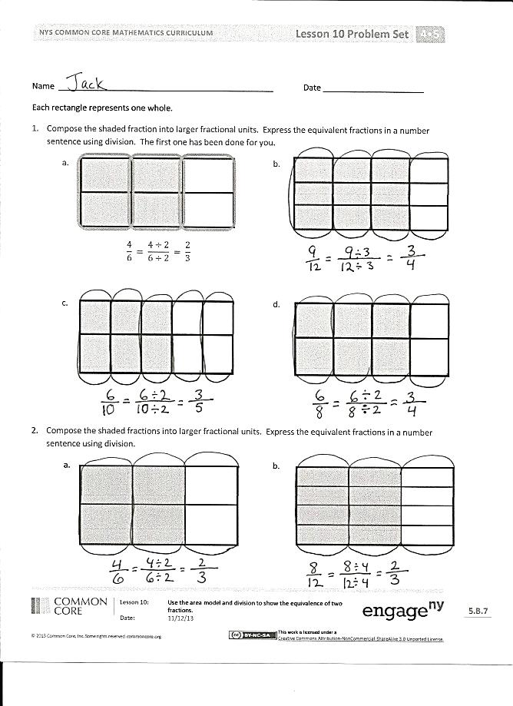

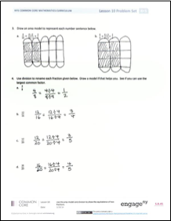

Name Date

Each rectangle represents 1.

1. Compose the shaded fraction into larger fractional units. Express the equivalent fractions in a number sentence using division. The first one has been done for you.

a. b.

c. d.

1. Compose the shaded fractions into larger fractional units. Express the equivalent fractions in a number sentence using division.

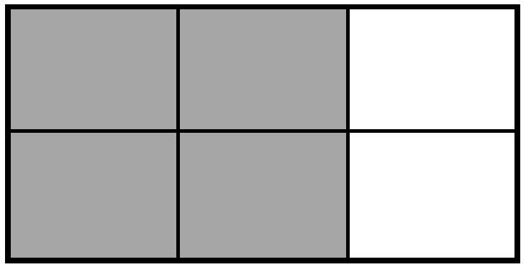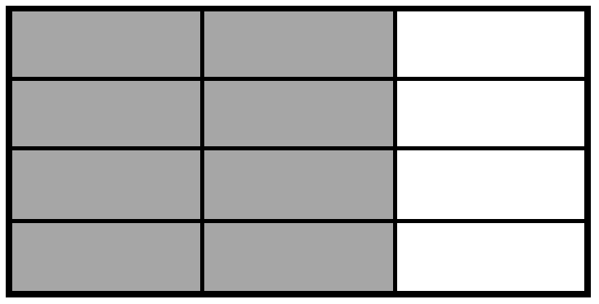a. b.

1. Draw an area model to represent each number sentence below.

a. $\frac{\text{4}}{\text{10}}\text{ =} \frac{\text{4} \text{÷} \text{2}}{\text{10} \text{÷} \text{2}}\text{ =} \frac{\text{2}}{\text{5}}$

b. $\frac{\text{6}}{\text{9}}\text{ =} \frac{\text{6} \text{÷} \text{3}}{\text{9} \text{÷} \text{3}} \text{=} \frac{\text{2}}{\text{3}}$

1. Use division to rename each fraction given below. Draw a model if that helps you. See if you can use the largest common factor.

$\frac{\text{4}}{\text{8}}$

$\frac{\text{12}}{\text{16}}$

$\frac{\text{12}}{\text{20}}$

$\frac{\text{16}}{\text{20}}$

Name Date

Draw an area model to show why the fractions are equivalent. Show the equivalence in a number sentence using division.

$\frac{\text{4}}{\text{10}}\text{ =} \frac{\text{2}}{\text{5}}$

Name Date

Each rectangle represents 1.

1. Compose the shaded fraction into larger fractional units. Express the equivalent fractions in a number sentence using division. The first one has been done for you.

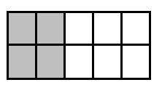a. b.

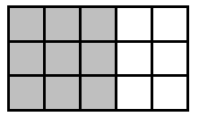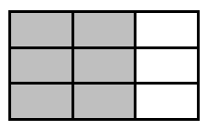c. d.

1. Compose the shaded fractions into larger fractional units. Express the equivalent fractions in a number sentence using division.
2. 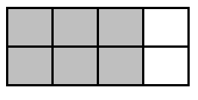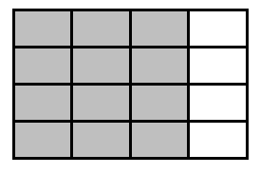 b.
3. Draw an area model to represent each number sentence below.

a. $\frac{\text{6}}{\text{15}} \text{= }\frac{\text{6}\text{ ÷ }\text{3}}{\text{15 }\text{÷}\text{ 3}} \text{= }\frac{\text{2}}{\text{5}}$ b. $\frac{\text{6}}{\text{18}}\text{ = }\frac{\text{6 ÷ 3}}{\text{18 ÷ 3}}\text{ = }\frac{\text{2}}{\text{6}}$

1. Use division to rename each fraction given below. Draw a model if that helps you. See if you can use the largest common factor.