Lesson 6: Area in the Real World

Mrs. Faour/Lesson Notes (Copy notes on your notebook/Submit by email or picture)

|  |
| --- |
| **Objectives:**   * Determine the area of composite figures in real-life contextual situations using composition and decomposition of polygons. * Determine the area of a missing region using composition and decomposition of polygons. * Finding area in real-world contexts can be done around the classroom, in a hallway, or in different locations around the world. * Area problems in the real world are all around us (covering an area with paint, carpet, tile, or wallpaper; wrapping a present; etc.) |

You are required to submit the following:

* Copy Notes/Math notebook
* Complete the Problem-Set (1-6)
* Exit Ticket

Problem Set

1. Below is a drawing of a wall that is to be covered with either wallpaper or paint. The wall is $8 ft.$ high and $16 ft.$ wide. The window, mirror, and fireplace are not to be painted or papered. The window measures $18 in.$ wide and $14 ft.$ high. The fireplace is $5 ft.$ wide and $3 ft.$ high, while the mirror above the fireplace is $4 ft.$ wide and $2 ft$. high. (Note: this drawing is not to scale.)

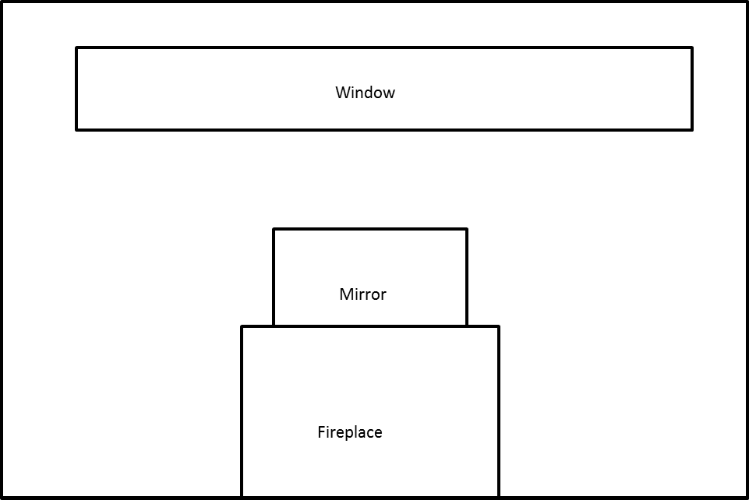

* 1. How many square feet of wallpaper are needed to cover the wall?
  2. The wallpaper is sold in rolls that are $18 in.$ wide and $33 ft.$ long. Rolls of solid color wallpaper will be used, so patterns do not have to match up.
     1. What is the area of one roll of wallpaper?
     2. How many rolls would be needed to cover the wall?
  3. This week, the rolls of wallpaper are on sale for $\$11.99$/roll. Find the cost of covering the wall with wallpaper.
  4. A gallon of special textured paint covers $200 ft^{2}$ and is on sale for $\$22.99$/gallon. The wall needs to be painted twice (the wall needs two coats of paint). Find the cost of using paint to cover the wall.

1. A classroom has a length of $30 ft.$ and a width of $20 ft$. The flooring is to be replaced by tiles. If each tile has a length of $36 in.$ and a width of $24 in.$, how many tiles are needed to cover the classroom floor?
2. A rectangular flowerbed measures $10 m$ by $6 m$. It has a path $2 m$ wide around it. Find the area of the path.

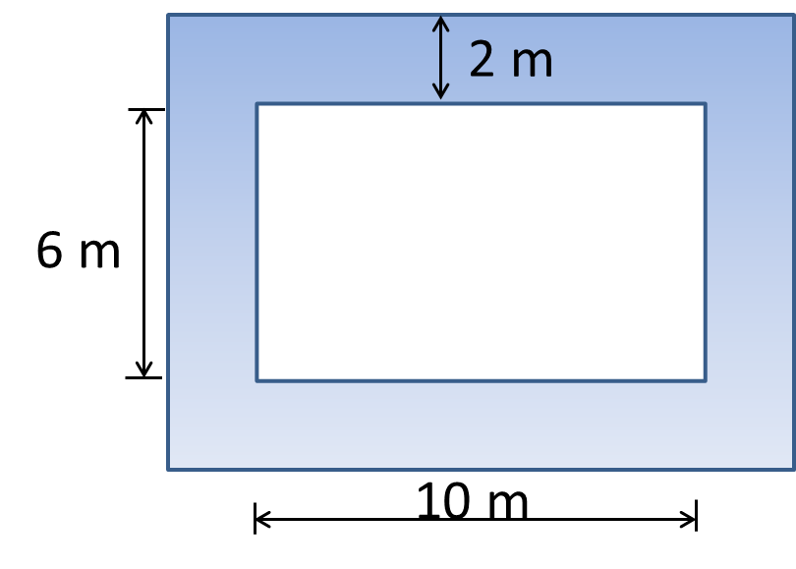

1. A diagram of Tracy’s deck is shown below, shaded blue. He wants to cover the missing portion of his deck with soil in order to grow a garden.
   1. Find the area of the missing portion of the deck. Write the expression and evaluate it.

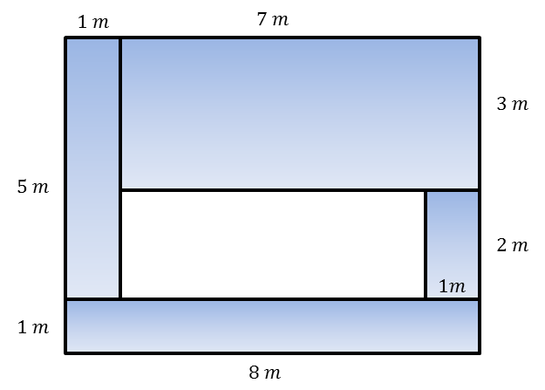

1. The entire large rectangle below has an area of $3\frac{1}{2} {ft}^{2}$. If the dimensions of the white rectangle are as shown below, write and solve an equation to find the area, $A$, of the shaded region.

