

Dear DiChiaro Community,

I am excited to be returning as the President of the DiChiaro PTA for a third year. As we begin this new year with our new normal, I am looking forward to trying to support the already strong community we have at DiChiaro!

This Fall we anticipate hosting a virtual book fair, a fall fundraiser, an online penny social and a social distant picture day (details to follow). As always, we welcome volunteers. So please reach out if you are interested in helping with any of these events. DiChiaropta@gmail.com

If you are not already following us on Facebook, Instagram and Twitter, please do so. It is a great source of information.

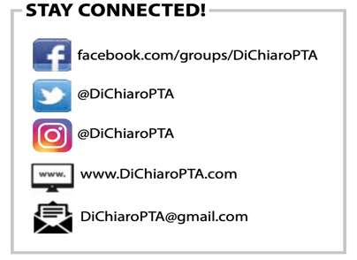

Periodically, the PTA will need to reach out to the community to distribute information. Currently, the only method for emailing families is through PTA membership. We are hoping to get 100% enrollment this year, not only so we can show NYS how active our PTA is, but also so we can get information to all our families. You can join the PTA by enrolling online using the link below. Link also available on Facebook. You can also enroll by sending $15 to DiChiaroPTA@gmail.com via Paypal. Please note the student’s name and PTA dues in note section. If finances are an issue, please email me directly and I will add you to our list (silkowskij@aol.com).

https://dichiaropta.memberhub.store/

The standard membership is $15. Additional children or adults in the house can be added for $5 additional per person.

8th grade parents, we are excited to celebrate your children. Judy Morel, PTA treasurer, has kindly volunteered to organize all 8th grade related activities. Please contact her at your earliest convenience to share the best email address to reach your family regarding these events (judy@morel5.com).

It certainly will be a new experience for all of us, but I am welcoming this opportunity to develop a closer bond with our community. As always, if there is anything the PTA can do to help or enhance your experience at school, please reach out.
2020-2021 OFFICERS
Johanna Silkowski
PRESIDENT
Judy Morel
TREASURER
Leanne Pantoliano
CORRESPONDING SECRETARY
Melissa Demelo
RECORDING SECRETARY

Sincerely,
Johanna Silkowski
President, DiChiaro PTA
(914) 760-8863

