Rights and Responsibilities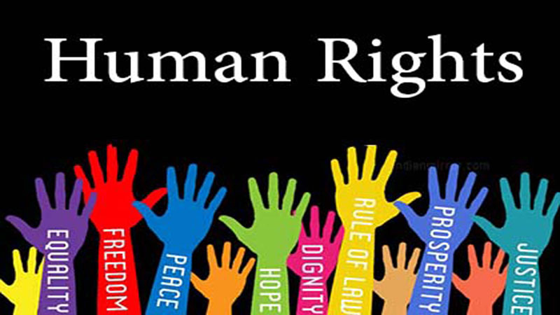

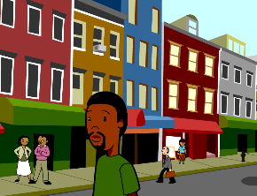

We all can become good CITIZENS

Learn about your rights and responsibilities. A citizen is a member of a COMMUNITY. Examples of a community: your classroom or school, or like a city, state, or country. The GLOBAL community includes EVERYONE on Earth.

Everyone is a member of a community and everyone has a responsibility to maintain the

COMMON GOOD. 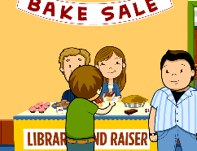

Some other different communities: family, sports team, club, religious groups, class, school, neighborhood, or town.

A RESPONSIBILTY is **something someone should do**.

A responsibility can be: a chore at home or school, following rules, helping others community

Obeying LAWS is an important responsibility.

A law is a rule that tells how to behave or act. 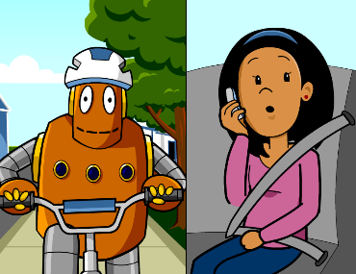

Laws help protect citizens’ rights. If a law is unfair, it is the community’s responsibility to change the law. Laws can be changed or amended when responsible citizens speak up and take action.

A RIGHT is a **freedom** that is protected.

Rights cannot be taken away from any citizen. Some rights include **freedom of speech**, **freedom of religion**, and **right to assembly**, which means people can gather and discuss.

Everyone has rights, but they also have responsibilities. 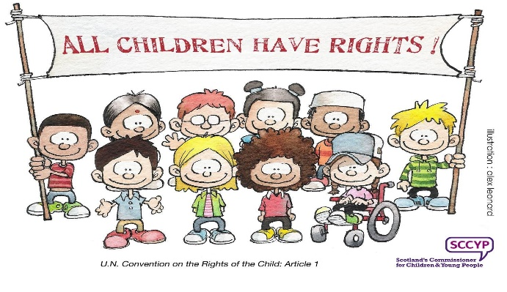 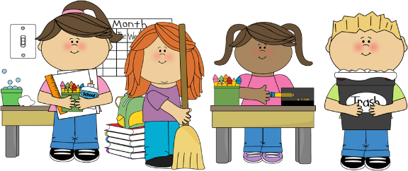

In school, every child has the right to learn, but every child has the responsibility of arriving to school on time, completing homework, and following school and class rules.

It’s your responsibility to become an active citizen and learn about issues that affect you in the classroom, at school, and in your community.