Instrucciones: Después de escuchar la historia, complete el cuadro con las palabras en el banco de palabras.
Directions: After you listen to the story, complete the chart with the words in the word bank.
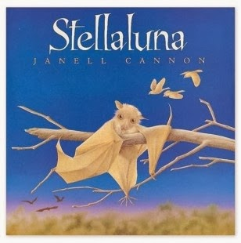
bats | both | birds
teeth | fly | colorful

feathers fly fur bugs wings hang upside-down

beak teeth colorful chirp eat fruit sleep in the day

only black, brown or grey fly at night eat sleep at night

