Name: Date:

**Peanut Butter and Jelly**

**Read.**

Nicki is hungry, so she decides to make a sandwich. First, she chooses two slices of bread. Then, she spreads peanut butter on one slice of bread.

Next, she spreads grape jelly on the other slice of bread. Nicki puts the two slices together and cuts her sandwich into two triangles. Finally, Nicki takes a big bite!

**Cut out the pictures and glue them in order to show the story’s sequence.**

|  |  |  |  |
| --- | --- | --- | --- |
| First | Second | Third | Last |
|  |  |  |  |

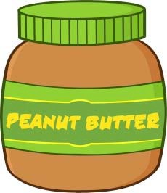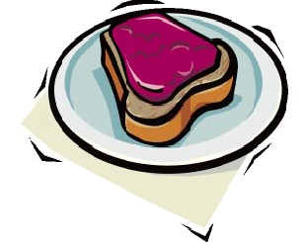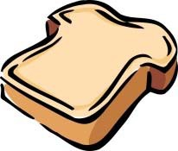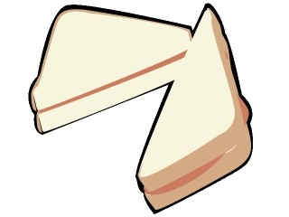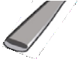

CCSS. RL.1.2 |© [http://www.englishworksheetsland.com](http://www.englishworksheetsland.com/)