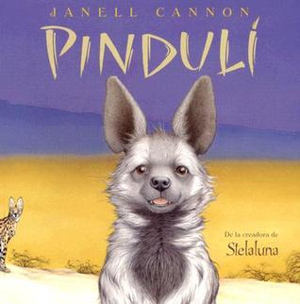

Haz un dibujo de la historia. Etiqueta tu foto.

Draw a picture from the story. Label your picture.

|  |
| --- |
|  |

¿Por qué los animales le tenían miedo a Pinduli?

Why were the animals afraid of Pinduli?

____________________________________________________________________________________________________________________________________________________________________________________________________________________________________________________________