**Mamo Is Trading Again!**

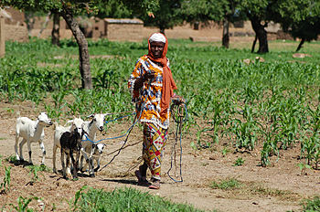

**Directions: Answer the questions in complete sentences.**

1. Who are the characters in the story? (page 2)

2. Where does the story take place? (Look at the picture and the cover.)

3. Why does Mamo’s father give him the game board? (page 5)

4. What did the man do with Mamo’s game board? (page 7)

5. Why did the goats run away from Mamo when he was playing his flute? (page 9)

6. Why was Mamo’s friend Zena crying? (page 17)

7. What kind of fruit does Desta sell? (page 23)

8. Why does Mamo begin to feel sad? (page 24)

9. What is Mamo’s problem and how does Hagos help him solve it? (page 31)

10. Why does Mamo smile at the end of the story when his father asks him if the board kept him out of trouble? (page 32)