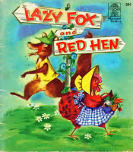

Haz un dibujo de la historia.

Draw a picture from the story.

|  |
| --- |
|  |

Cuenta cómo la gallinita roja engañó al zorro.

Tell how the Little Red Hen tricked the fox.

______________________________________________________________________________________________________________________________