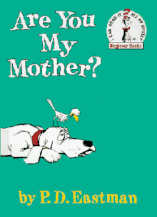

Haz un dibujo de ti y tu madre. ______________________________________

Draw a picture of you and your mother.

|  |
| --- |
|  |

Escribe una oración sobre lo que tu madre hace por ti. __________________________________________

Write a sentence about what your mother does for you.

______________________________________________________________________________________________________________________________