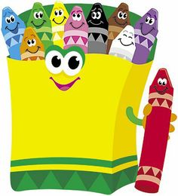

**Ms. Gould, Mrs. Parandian & Ms. Nesheiwat’s Pre-Kindergarten Supply List (please label all supplies with your child’s name) For the 2024-2025 School Year!**

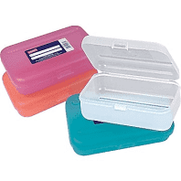**⃝ Plastic pencil box** with 10 **sharpened** chubby, beginner pencils, 2 glue sticks, 1 box of chubby crayons and 1 box of colored pencils

⃝ A watercolor kit

⃝ 4 packs of glue sticks, 2 packs of crayons, 1 pack of dry erase markers & 1 pack of markers

⃝ Two Vinyl folders

⃝ A change of clothing (in case of accidents – labeled with their name, in a gallon-sized zip-lock baggie with socks and underwear).

⃝ **$10.00* (in an envelope labeled with your child’s name)** for the cost of a year's subscription to an educational magazine (“My Big Day”) and consumable items we use each year.

⃝ Small blanket or towel labeled with your child’s name for rest time

⃝ 3 packs of Play-Doh

⃝ 1 plastic shoe box to keep their blanket & change of clothes in

Thank you so much!

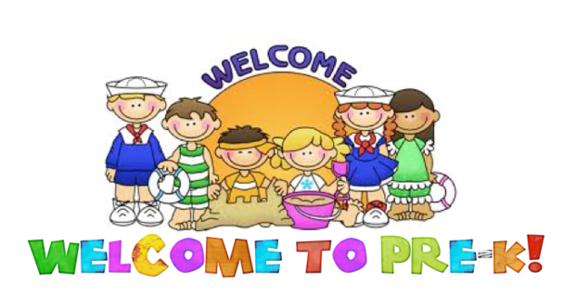

The following are items we use a lot in Pre-Kindergarten and would really appreciate during the first month of school. If possible, could your family donate:

Purell or any antibacterial hand sanitizer

Clorox wipes for tables

Clorox or Lysol Spray

Paper Towels

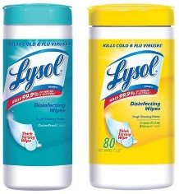Napkins

Baby Wipes

Tissue boxes

Hand Soap

Ziplock Baggies (various sizes)

Brown paper lunch bags

Plain white paper plates

Thanks so much!