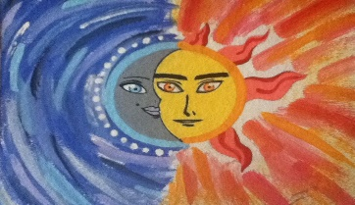

**I Am La Luna**

1. Who are the characters in the story? (page2)

2. Why do you think El Sol loves La Luna? (page 9)

3. What does El Sol ask La Luna? (page 10)

4. Do you think La Luna wants to marry El Sol? Why or why not? (page 12)

5. Describe how does the story ends?