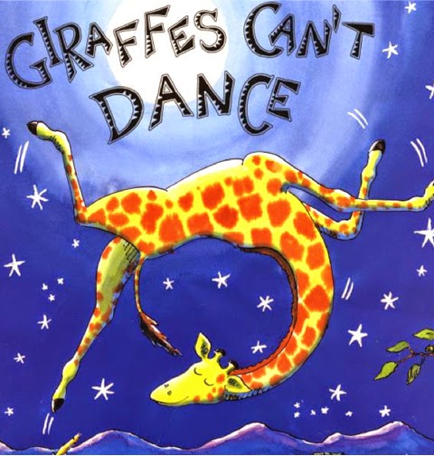

Haz un dibujo de tu parte favorita de la historia. _____________________________________________

Draw a picture of your favorite part in the story.

|  |
| --- |
|  |

Cuéntele sobre su imagen en una oración completa.

Tell about your picture in a complete sentence.

______________________________________________________________________________________________________________________________