Directions: Write all the words that begin with the letter “Q” on a piece of paper. Think of some more that are not here.
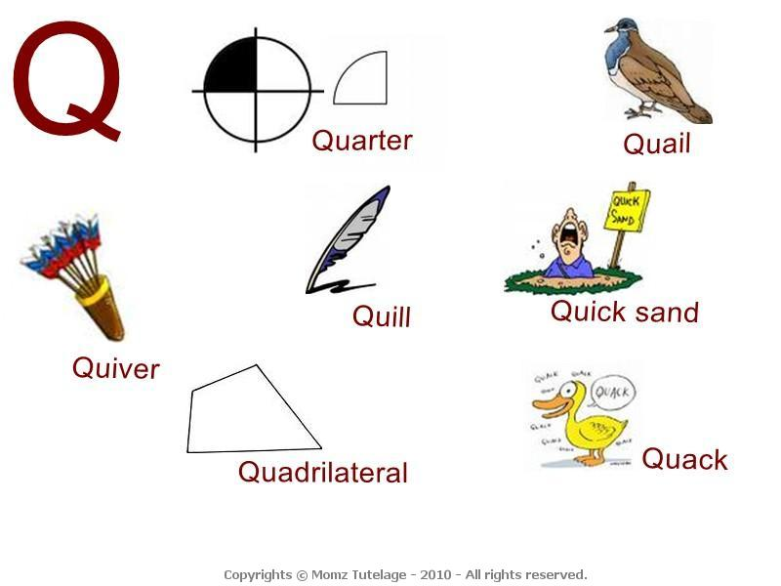
This Photo by Unknown Author is licensed under CC BY-NC-ND

