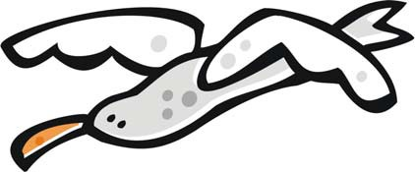**Read the story and answer the questions.**

Flying

John’s father drives over a bridge. The bridge is very high. Far below, the blue water sparkles. The sails of boats look like white specks. John puts his arm out of the window and lets it ride on the wind. This is how it must feel to be a bird, he thinks.

1. **Where is John?**
2. **What does he see? What does he do? How does it make him feel?**

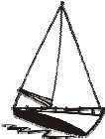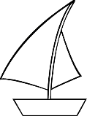

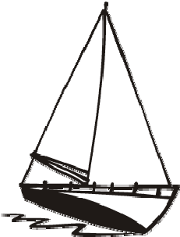CCSS. RL.1.4 |© [http://www.englishworksheetsland.com](http://www.englishworksheetsland.com/)