Name Letters of the Alphabet

**Letter Fun**

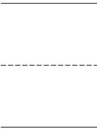**DIRECTIONS**: Write each set of letters in order.



|  |  |  |
| --- | --- | --- |
| 1. q | s | r |
| 2. e | g | f |
| 3. k | i | j |
| 4. v | x | w |
| 5. i | h | g |

CCSS.RF.K.1.D | © [www.EnglishWorksheetsLand.com](http://www.EnglishWorksheetsLand.com/)

