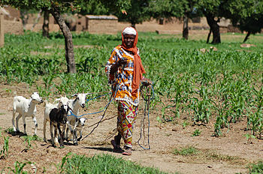

**Mamo Is Trading Again!**

**Haz un dibujo de la historia.**

**Draw a picture from the story.**

|  |
| --- |
|  |

**Escribe una oración completa sobre tu dibujo.**

**Write a complete sentence about your drawing.**

**______________________________________________________________________________________________________________________________________________________________________________**