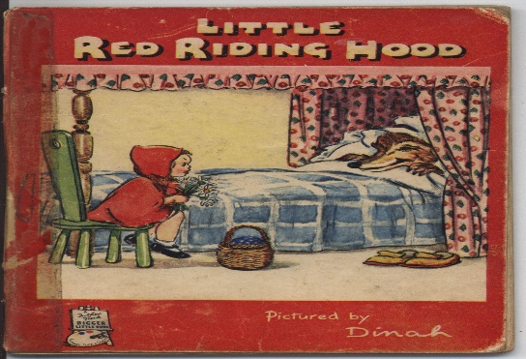

Haz un dibujo de la historia.

Draw a picture from the story.

|  |
| --- |
|  |

Contar ¿Cómo sabía Caperucita Roja que no era su abuela en la cama?

Tell how did Little Red Riding Hood knew it was her not her grandmother in the bed?

______________________________________________________________________________________________________________________________