Juan Bobo Goes Up and Down the Hill
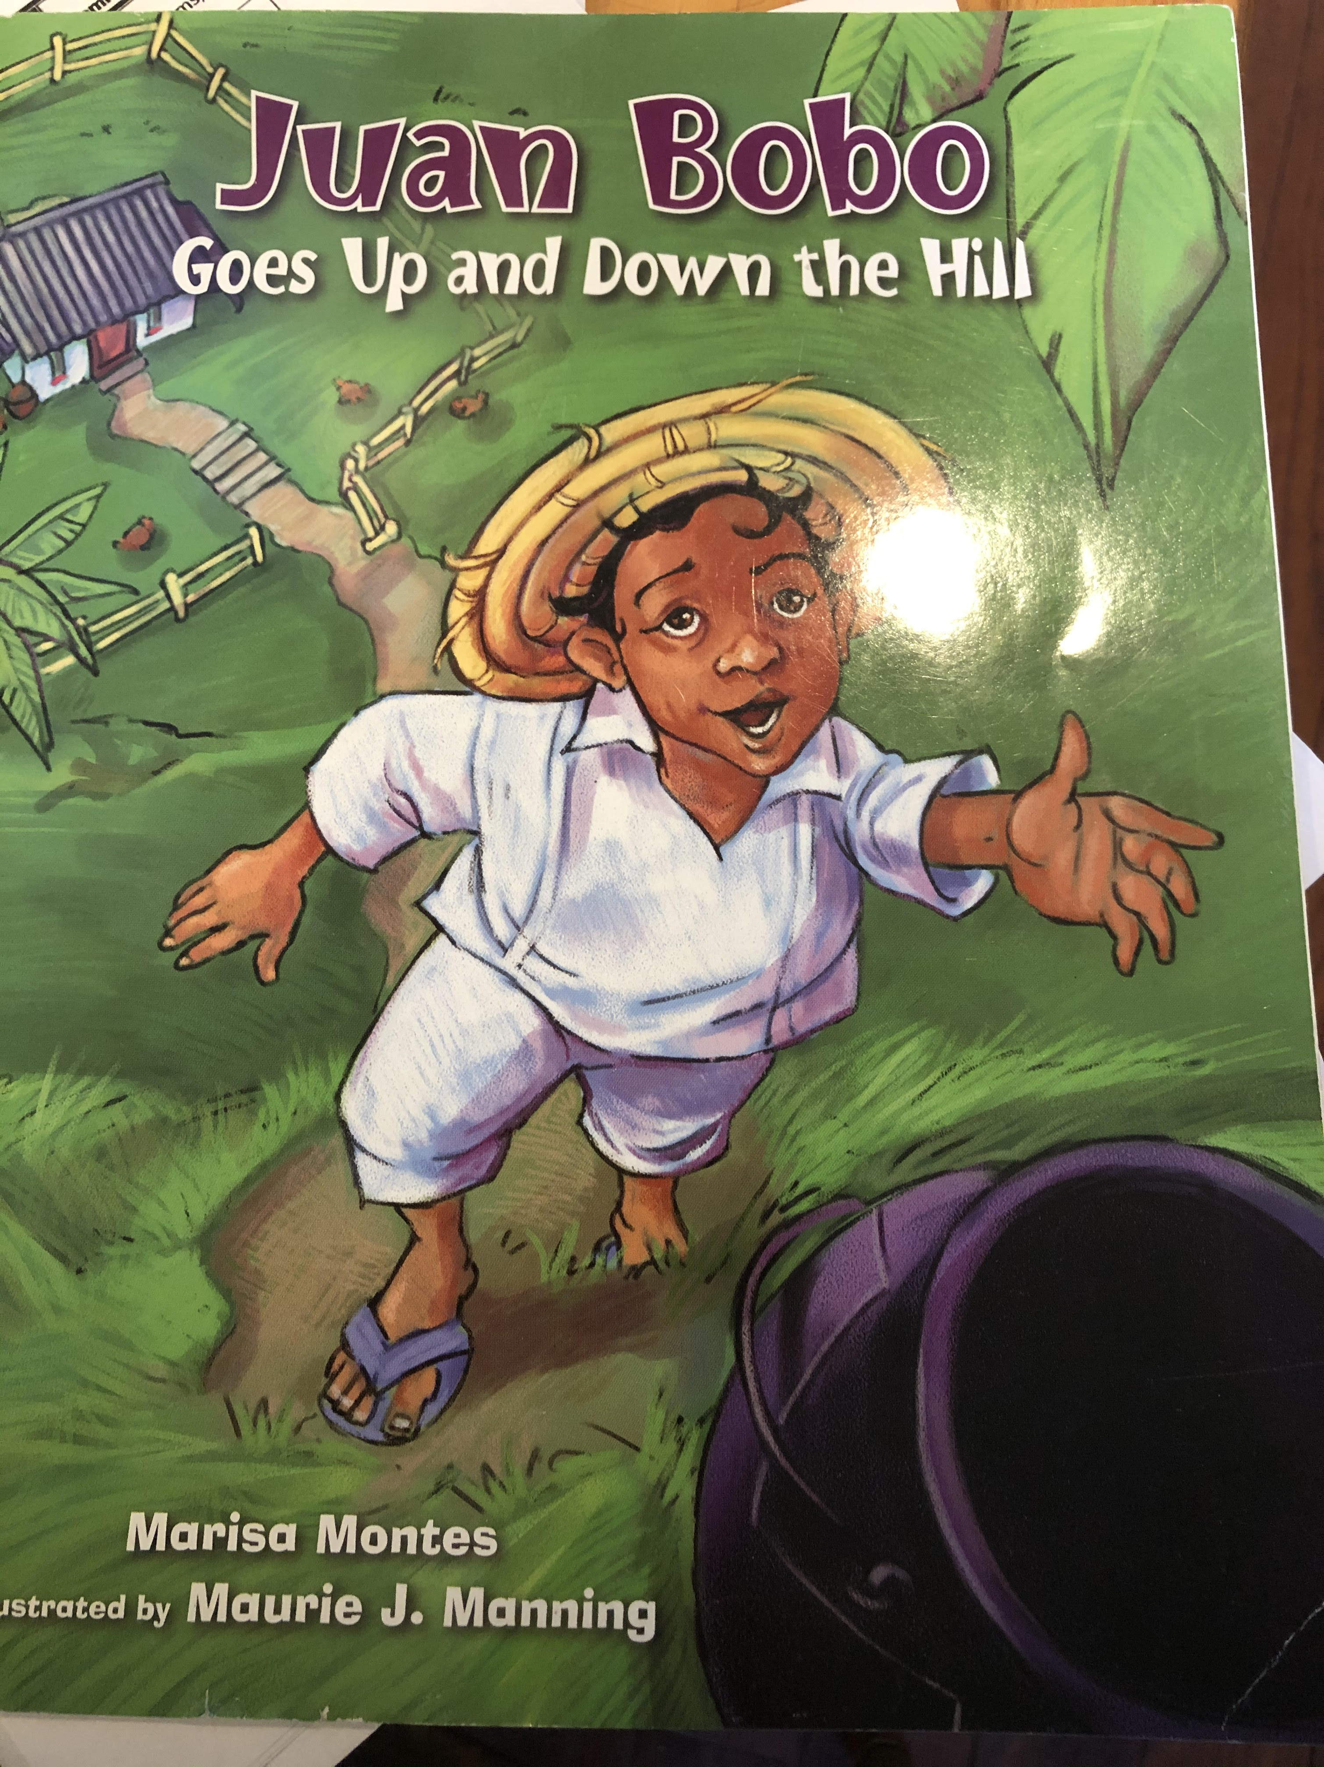
Haz un dibujo de la historia.
Draw a picture from the story.
Escribe una oración completa sobre tu dibujo.
Write a complete sentence about your drawing.
______________________________________________________________________________________________________________________________________________________________________________

