Name: Date:

**The Camping Trip**

**Read.**

Michael and his brother are going camping. First, they put on their backpacks and hike into the woods. Then, they set up a tent. Next, they build a campfire. They roast hot dogs and marshmallows over the campfire. Finally, they tell spooky ghost stories until it is time for bed.

**Cut out the pictures and glue them in order to show the story’s sequence.**

|  |  |  |  |
| --- | --- | --- | --- |
| First | Second | Third | Fourth |
|  |  |  |  |

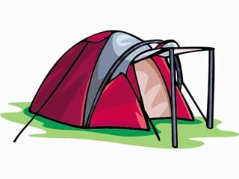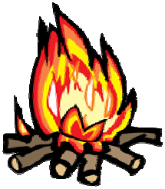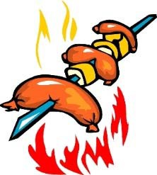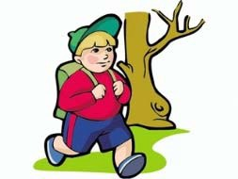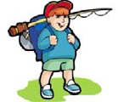

CCSS. RL.1.2 |© [http://www.englishworksheetsland.com](http://www.englishworksheetsland.com/)