

**Steps to Log into Microsoft for Students**

1. **Go to your web browser**

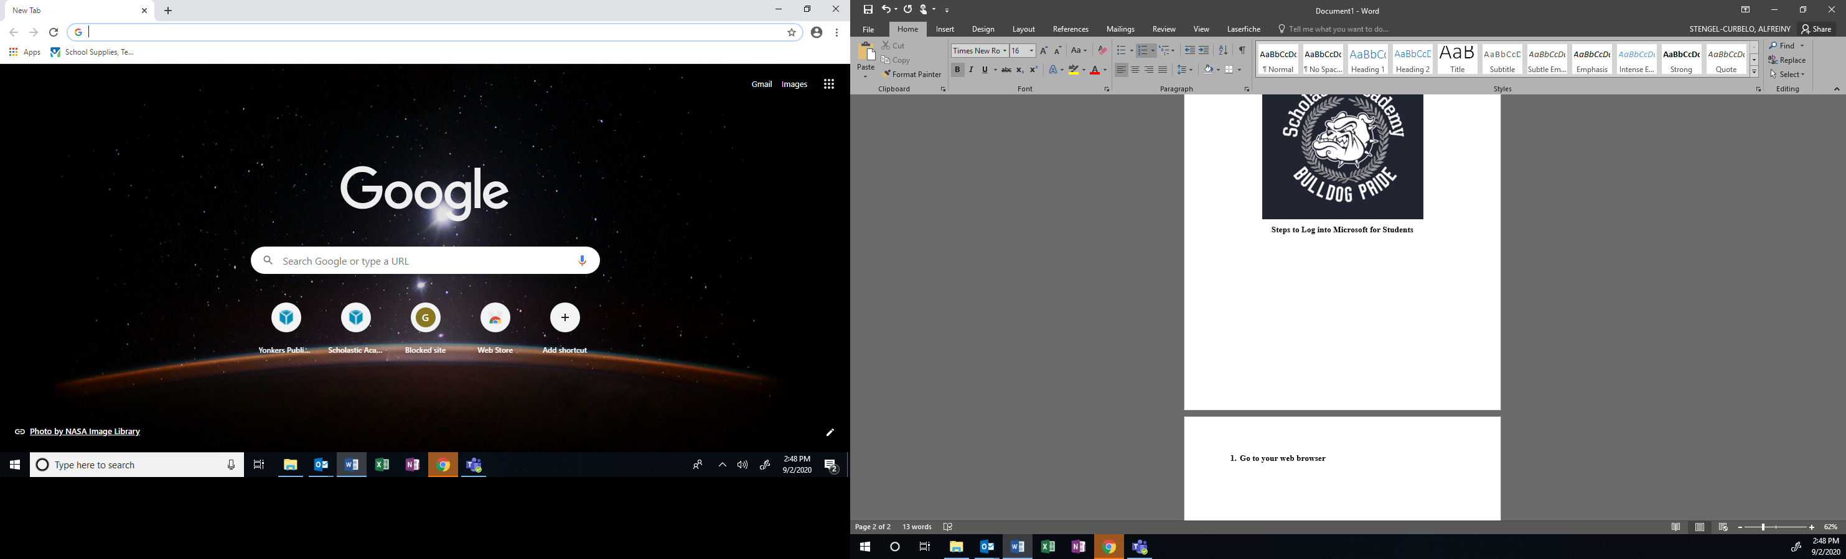

1. **In the web bar type:**

**Yonkerspublicschools.org**

1. **Press Enter**

**You should see the YPS main page – See below**

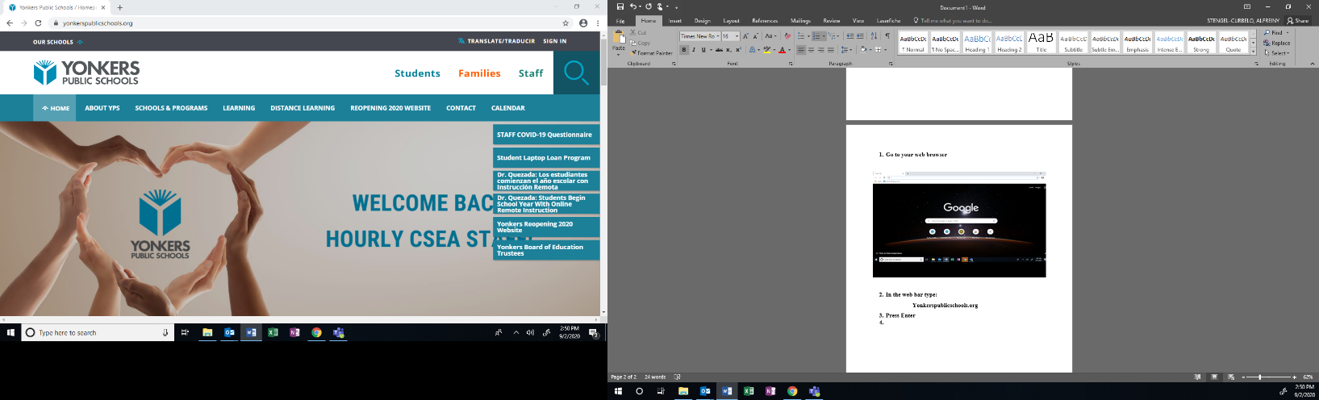

1. **Scroll down to the bottom**

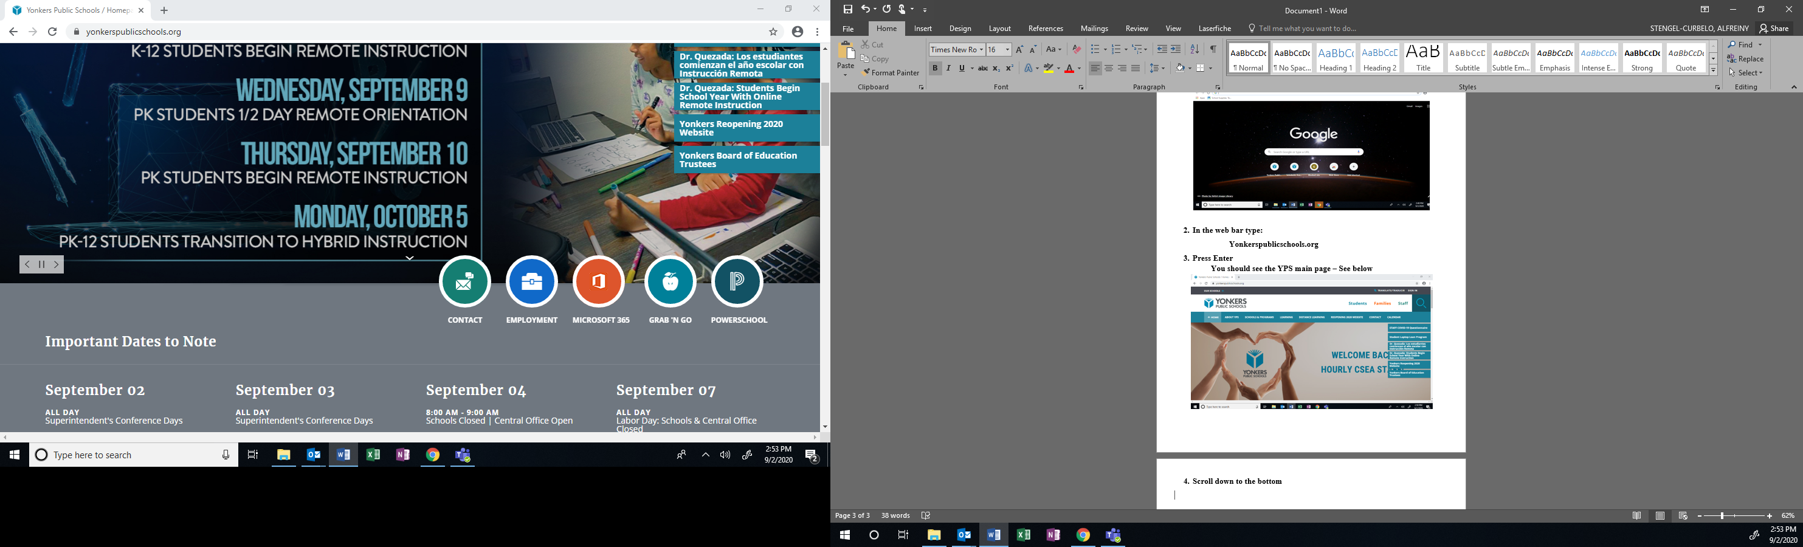

1. **Click on the orange circle- Microsoft 365**

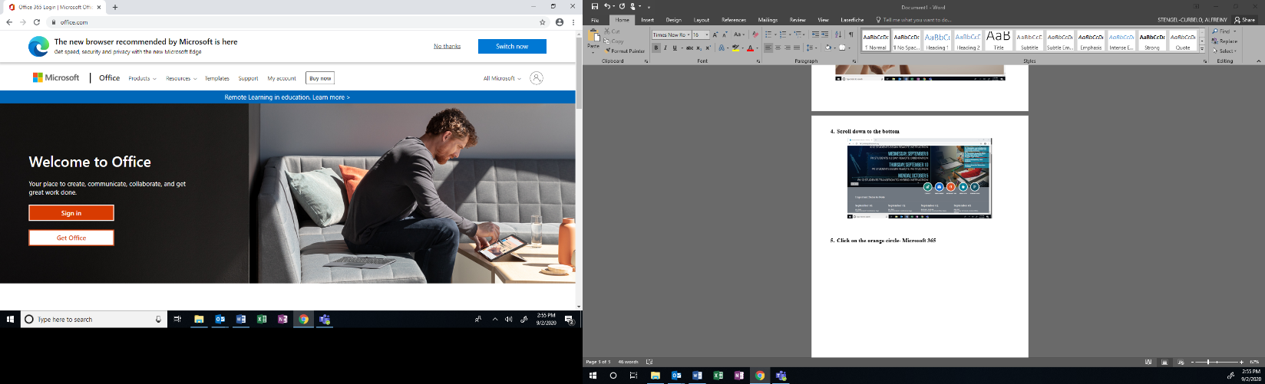

1. **Click Sign in**

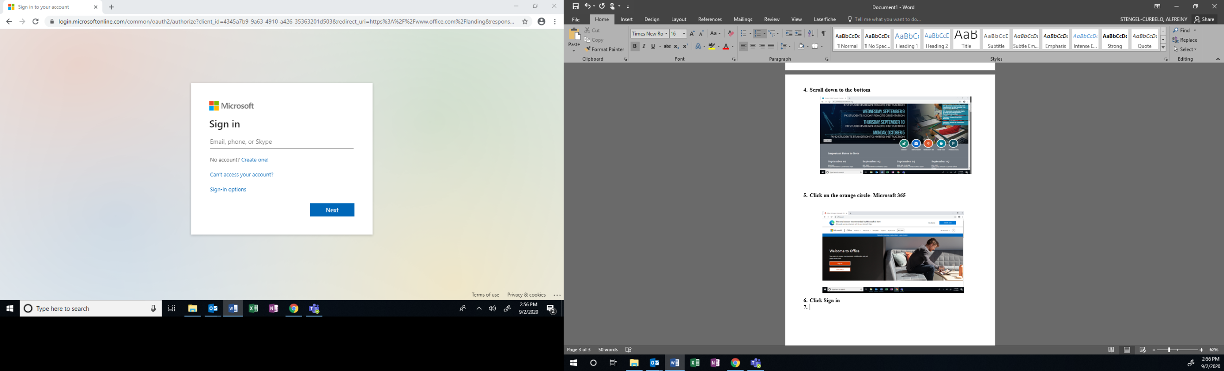

1. **Your email is:** 
   * 1. **Your student id (6 digits) @yonkerspublicschools.org**

**Example:** [**123456@yonkerspublicschools.org**](mailto:123456@yonkerspublicschools.org)

**Your password is your birthday in the following format:**

**MMDDYYY**

**Example: DOB is : 01/28/2001 enter it as: 01282001**

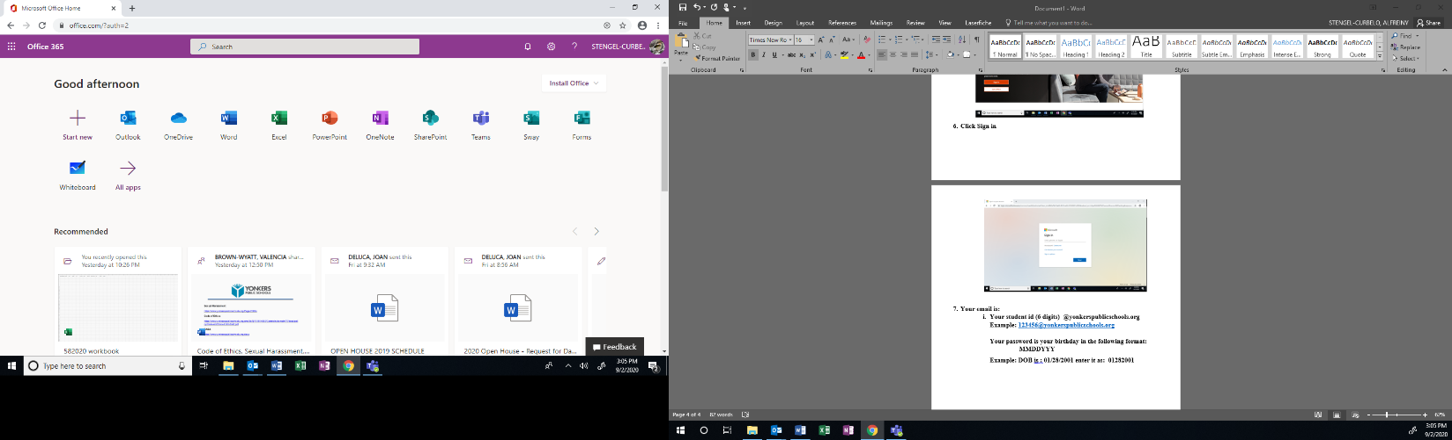

1. **Click on the Teams icon to download**

**Happy Learning!**

**If you are using a Loaner laptop:**

1. **Start up your laptop**
2. **Your ID is**

**ypsloaner**

1. **Your password is:**

**Spring2020**