Ms. Stephenson’s Class 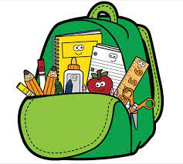

Supply List

* Tissues (2 boxes)
* Paper Towels
* 24 Pencils
* 1 Marble Notebook
* 5 plastic two-pocket folders (1 red, 1 yellow, 1 green, 1 blue, 1 purple)
* 3 packs Antibacterial Hand Wipes
* Erasers (1 pack pencil top, 1 pack pink rectangle)
* Disinfectant wipes (Lysol or Clorox)
* Disinfectant spray
* Change of clothes (in a labeled plastic bag)
* Laminating sheets
* One pack Ziplock bags (gallon or quart size)
* Headphones (Labeled)
* Expo Dry Erase Markers (wide or thin)
* 2 Glue sticks
* 1 pack printer paper
* 1 pack loose leaf paper

\*\*\*Please send your child to school with a healthy snack and drink (preferably water) each day

· Another supply list may be sent home once I know the needs of the students.