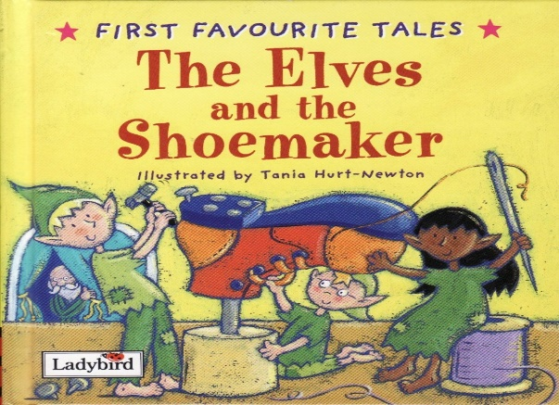

Haz un dibujo de los elfos haciendo los zapatos.

Draw a picture of the elves making the shoes.

|  |
| --- |
|  |

Di **por qué** crees que los elfos hicieron los zapatos para el Zapatero.

Tell **why** you think the elves made the shoes for the Shoemaker.

________________________________________________________________________________________________________________________________________________________________________