Eating Healthy Foods

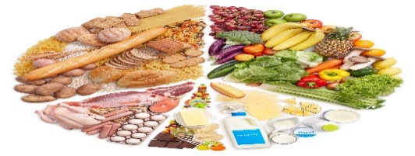
This Photo by Unknown Author is licensed under CC BY-NC-ND

It is important to eat to get energy. Too little food or the wrong food doesn’t give you enough energy. If you eat too much you need to exercise more or you will gain weight.

Fat is high in calories and is not good for your heart. Too much sugar is not good either, because it can cause you to gain weight and it is very bad for your teeth.

Eating fiber is very good for you. It is important to eat bread with lots of grains. Vegetables, such as broccoli and carrots and fruits, such as apples and blueberries help keep you healthy too. Potatoes are very good for you and fill you up.

In conclusion, eat fewer fatty foods (sweets, chocolate, pudding) and more fiber foods (bread, potatoes, pasta, fruits and vegetables).
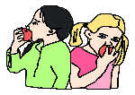
Comprehension

True or False

- You should exercise more if you eat too much. ______________
- Sugar is very good for your teeth. ______________________
- Bananas are a type of fruit. ______________________

Answer the question in 1-2 sentences. Why is exercise good for your health?

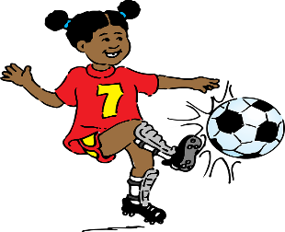
This Photo by Unknown Author is licensed under CC BY

