Image 8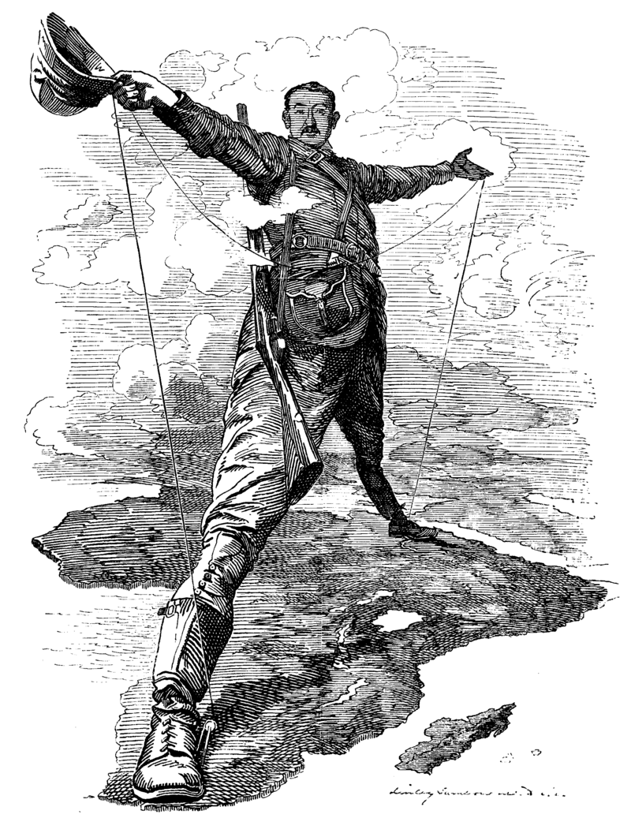

The Rhodes Colossus Striding from Cape Town to Cairo Punch
10 December 1892 (Edward Linley Sambourne)
Source: https://en.wikipedia.org/wiki/The_Rhodes_Colossus#/media/File:Punch_Rhodes_Colossus.png
Image 9
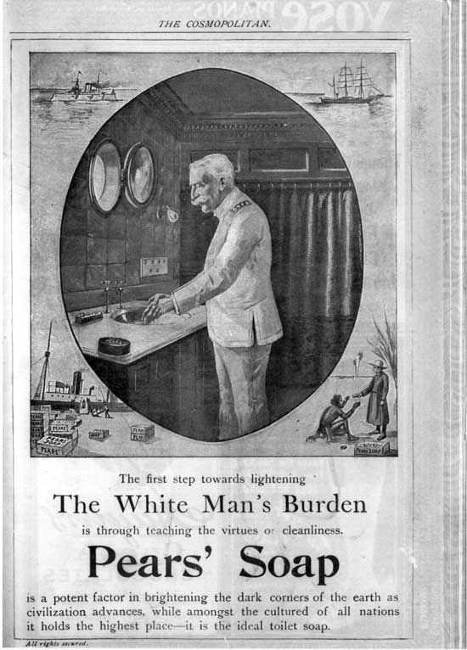

Pears' Soap Company, LIGHTENING THE WHITE MAN'S BURDEN (1899)
Source: http://www.learner.org/courses/amerhistory/resource_archive/zoom.php?unitChoice=16&ThemeNum=1&resourceID=10143

Image 10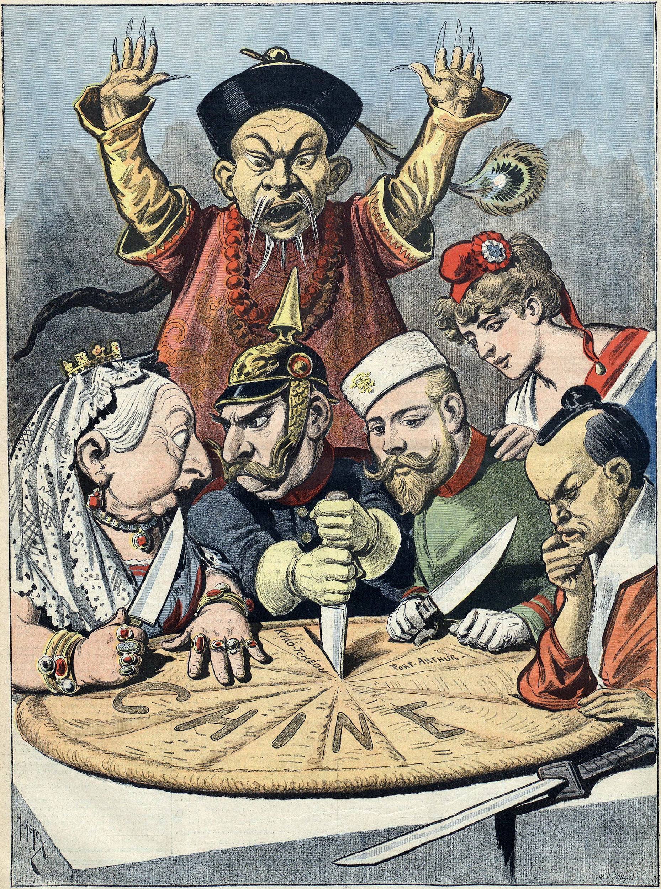
"China -- the cake of kings and... of emperors" (a French pun on king cake and kings and emperors wishing to "consume" China). French political cartoon from 1898
Source: https://commons.wikimedia.org/wiki/File:China_imperialism_cartoon.jpg
Image 11
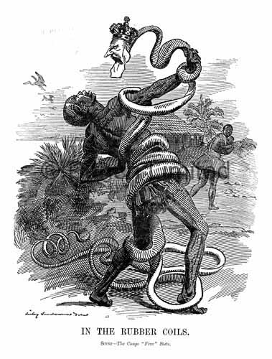
"In The Rubber Coils. Scene - The Congo 'Free' State" (1906)
Source: https://upload.wikimedia.org/wikipedia/commons/8/80/Punch_congo_rubber_cartoon.jpg

Image 12
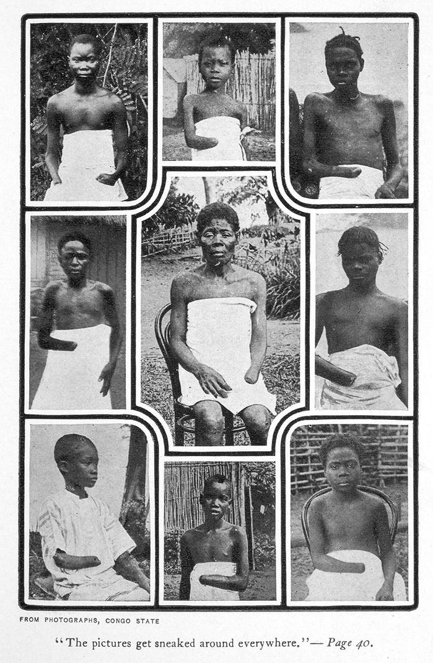

Photographs from the Congo Free State
Mutilated Congolese children and adults (c. 1900-1905) — in Belgian colonial Congo Free State which was a privately owned territory of Belgian King Leopold II. He had numerous rubber collection/production areas in the rainforest and on plantations where Africans were enslaved and forced to collect rubber. Rubber producers used cruel punishments against the Congolese people, including amputations for not gathering enough rubber. From: Alice Harris - King Leopold's Soliloquy: A Defense of His Congo Rule, By Mark Twain, Boston: The P. R. Warren Co., 1905, Second Edition.
Source: https://en.wikipedia.org/wiki/Leopold_II_of_Belgium#/media/File:MutilatedChildrenFromCongo.jpg

