Directions: Write all the words that begin with the letter “U” on a piece of paper. Think of some more that are not here.

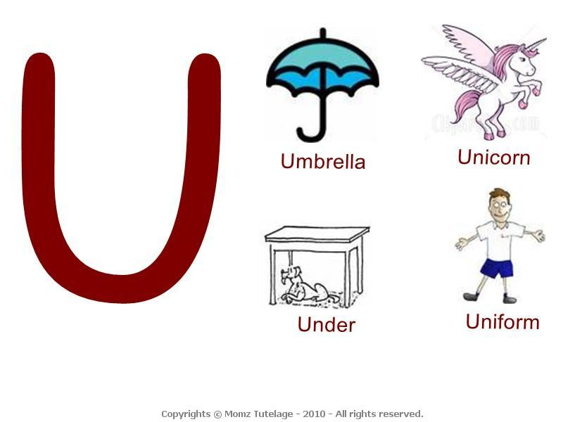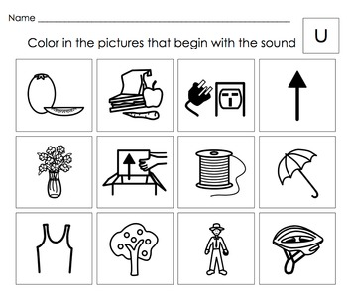

[This Photo](https://www.teacherspayteachers.com/Product/Beginning-Letter-Sounds-Activities-Letters-STU-shortVWXYZ-Set-4-1685520) by Unknown Author is licensed under [CC BY-NC-ND](https://creativecommons.org/licenses/by-nc-nd/3.0/)

