**4th Grade Supply List**

**2024-2025**

* 1 pack of colored pencils
* 1 pack of markers
* 2 glue sticks
* 4 wide-ruled marble composition books
* 1 pack of **thin** black dry-erase markers
* 1 multi-color pack of **thick** (“chisel tip”) dry-erase markers
* 6 plastic 2-pocket folders (1 blue, 1 green, 1 orange, 1 red, 1 yellow, 1 black)
  + Blue – Sci. / Soc. St.
  + Green – Math
  + Orange – Home Folder
  + Red – ELA
  + Yellow – ELA
  + Black - ELA
* 4 highlighters
* 1 wide-ruled 5-subject spiral notebook with **pockets** inside
* 1 100ct pack of **wide-ruled** filler/ loose leaf paper
* 12 packs of **SHARPENED** pencils
* 2 enclosed pencil sharpeners
* 12 blue or black erasable pens (erasable GEL pens preferred, such as Frixion brand)
* 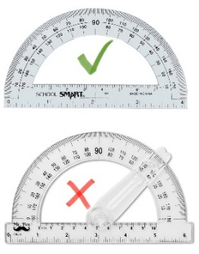2 protractors (**no ‘swinging arm’**- refer to photo)

*Keep one protractor at home*

* 1 ruler with inches and centimeters
* 1 pair of earbuds or headphones
* 1 Pencil case with name label
* 3 boxes of tissues
* 3 rolls of paper towels
* 3 packs of baby wipes or sanitizing wipes
* 1 combination lock (no key locks) *please practice opening lock at home*
* 1 homework assignment planner

Optional:

* 1 bottle of hand sanitizer
* 1 pack of Ziploc bags, quart or gallon.

😊 **PLEASE LABEL** ALL ITEMS WITH STUDENT’S FIRST AND LAST NAME. For items that come in a pack, please open the pack and label each individual item.