Lots of Cats

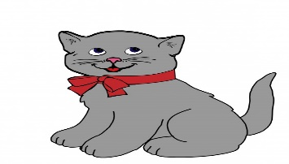
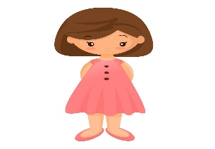  _________ have a cat.  This is ____________ cat.  This cat is _________________. | my  I  mine
  This is Jen.  _________________ has a cat.  This is _________________ cat.  This cat is __________________. | hers  her  She
  This is Max.  __________________ has a cat.  This is ________________ cat.  It belongs to _______________. | him  He  his

