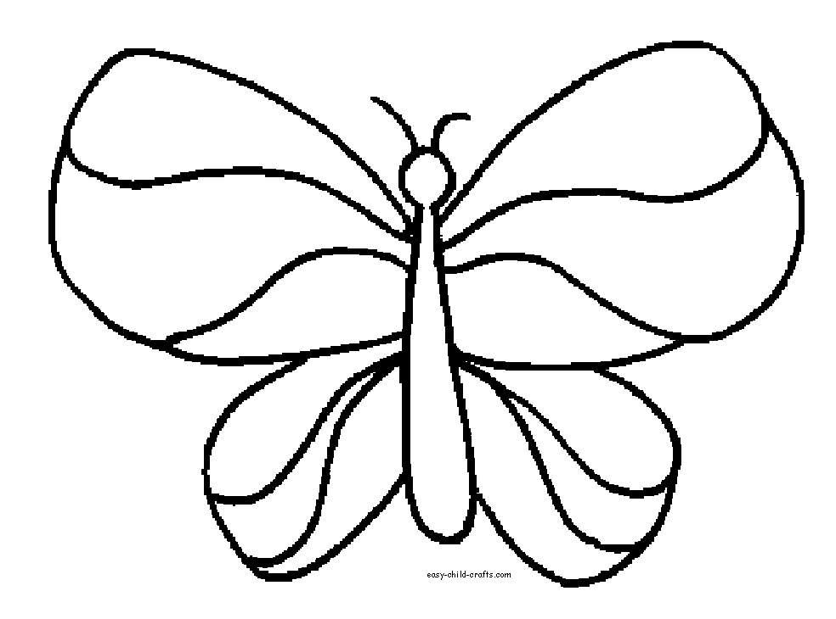

she

she

over

over

she

she

her

her

her

over

over

her