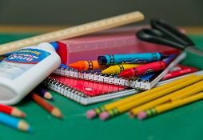**Second Grade Supply List 2022-2023**

**2 black and white notebooks (no spiral notebooks)**

**4 Composition Notebooks: red, blue, green, yellow (no spiral notebooks)**

**4 PLASTIC 2-pocket folders: red, blue, green, yellow**

**1 packet of wide ruled loose-leaf paper**

**2 boxes of 24 sharpened pencils**

**3 highlighters: green, pink, blue**

**1 box of 24 crayons**

**1 pack of 4 glue sticks**

**1 pair of scissors**

**1 large/soft pencil case (no hard containers)**

**6 dry erase markers**

**1 headset/headphones for computer use labeled in a zip lock bag with name**

**2 boxes of tissues**

**1 pack of sanitizing wipes**

**1 container of Clorox/ Lysol wipes**

**I roll of paper towels**

**Hand Sanitizer for the class**

**1 box of the gallon size Ziploc bags**

**1 package of lined Post it Notes (3x 5)**

Please make sure your child’s name is clearly written on all the supplies. I look forward to working with you and your child this coming school year. If you have any questions or concerns, please feel free to contact us at the school at 914-376-8969. Thank you in advance for your support and cooperation.

Sincerely,

Mrs. Tarantino