Name: ___________________________

Directions: Rewrite each sentence correctly. Begin each

sentence with a capital letter and add punctuation.

**Sharks**

1. sharks live in the ocean

1. have you ever seen a shark

1. watch out for that shark

1. jane and alex saw one at the beach

1. there are many sharks in florida



* I used capital letters.
* I used spaces.
* I used punctuation.

Name: ___________________________

Directions: Rewrite each sentence correctly. Begin each

sentence with a capital letter and add punctuation.

**Snakes**

1. snakes have scales on their skin

1. snakes shed their skin

1. snakes eat meat from animals

1. some snakes can be very large

1. have you ever seen a snake

* 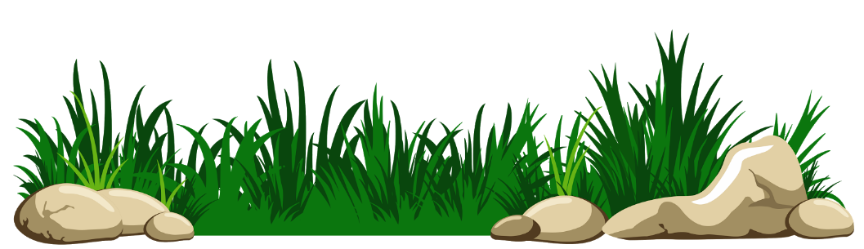 I used capital letters.
* I used spaces.
* I used punctuation.

Name: ___________________________

Directions: Rewrite each sentence correctly. Begin each

sentence with a capital letter and add punctuation.

**Birds**

1. birds have wings and feathers

1. birds use their beak to eat

1. some birds eat meat

1. birds build nests and lay eggs

1. what is your favorite bird



* I used capital letters.
* I used spaces.
* I used punctuation.

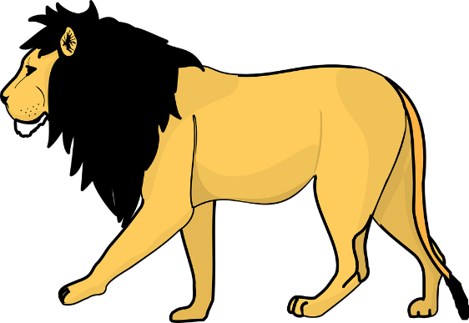Name: ___________________________

Directions: Rewrite each sentence correctly. Begin each

sentence with a capital letter and add punctuation.

**Big Cats**

1. there are many kinds of big cats

1. do you like big cats

1. cheetahs can run very fast

1. leopards like to lay in trees

1. lions live in africa

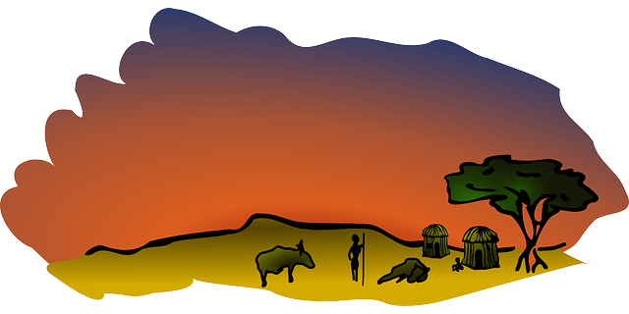

* I used capital letters.
* I used spaces.
* I used punctuation.

Name: ___________________________

Directions: Rewrite each sentence correctly. Begin each

sentence with a capital letter and add punctuation.

**School**

1. i love to go to school

1. we learn many things

1. what class are you in

1. i like playing at recess

1. jack and ellie are my friends

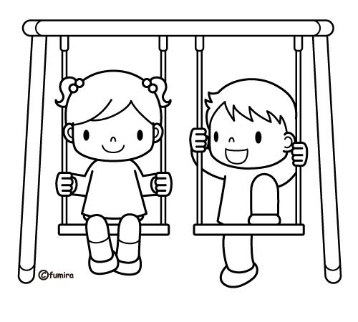

* I used capital letters.
* I used spaces.
* I used punctuation.

Name: ___________________________

Directions: Rewrite each sentence correctly. Begin each

sentence with a capital letter and add punctuation.

**Snow Day**

1. today is a snow day

1. i am so excited to play

1. has it ever snowed in louisiana

1. gabbie and tim will build a snowman

1. the snow is cold and wet



* I used capital letters.
* I used spaces.
* I used punctuation.

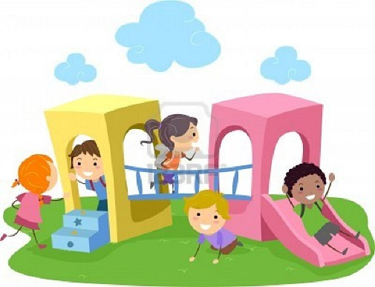Name: ___________________________

Directions: Rewrite each sentence correctly. Begin each

sentence with a capital letter and add punctuation.

**Friends**

1. i have many friends

1. they are nice to me

1. we play games together

1. who is your friend

1. my friends are zach and hannah

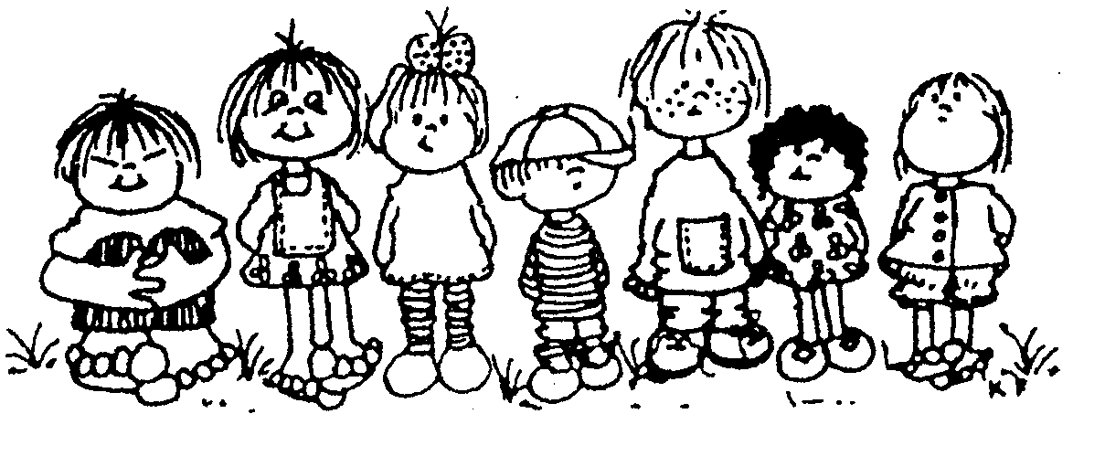

* I used capital letters.
* I used spaces.
* I used punctuation.