Name Recognizing Words

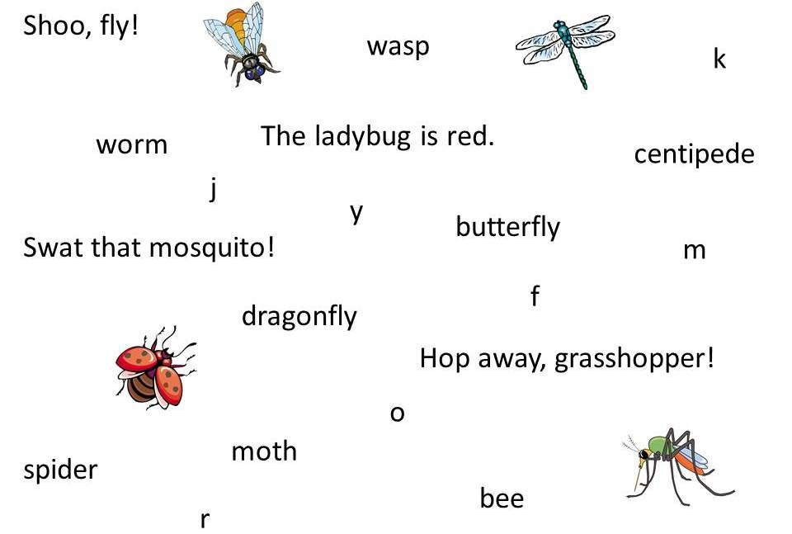

**Bugs!**

Circle the words below. Underline the complete sentences.

CCSS.RF.K.1.C | © [www.EnglishWorksheetsLand.com](http://www.EnglishWorksheetsLand.com/)

CCSS.RF.K.1.C | © [www.EnglishWorksheetsLand.com](http://www.EnglishWorksheetsLand.com/)