27 Poplar Street

Yonkers, New York 10701

Tel. 914 376-8460

Fax 914 376-8468

mametrano@yonkerspublicschools.org

**Dr. Edwin M. Quezada**

Superintendent of Schools

**Dr. Andrea S. Coddett**

Assistant Superintendent  
Curriculum, Instruction, School Supervision Elementary Administration

**Mark Ametrano**

Principal

Enrico Fermi School

September 2020

Dear Parents,

We will be using Microsoft Teams to foster connection between students and teachers and remote learning instruction. Microsoft Teams is part of the Office 365 suite, which we use in our district in a variety of ways.

Microsoft Teams is accessible from multiple devices (laptop, iPad, tablet, or cell phone). When scheduled, your student will be able to join a call and see their teachers live. If your family is sharing a device, your student can watch a recording of the live call when their schedule allows. Additionally, your students can also access pre-recorded lesson and other activities your teacher creates.

If you are using a cell phone to connect, you can download the Microsoft Teams app (from App Store). If you are using an iPad or a Mac computer, you will also want to download the Microsoft Teams app from the App Store. (Be sure to also download the Word, PowerPoint, and Stream app to make your student’s workflow more efficient).

If your child will access Microsoft Teams by laptop or tablet go to the Internet and type portal.office.com into to the URL bar.

From whatever device you access Microsoft Teams you will use the following login for your student – for Office 365.

**Username: Students’ Identification Number Example:**[**123456@yonkerspublicschools.org**](mailto:123456@yonkerspublicschools.org)

**Password: Students’ Full Birth-date**

**Example: 03121985**

To ensure everyone knows how to join a Teams call, we are sharing the following directions:

**1. Login to Office 365 (portal.office.com)**

**2. Select the Teams icon**

3. When students reach the Teams page, they will see icons for their class period that they have with me. (This will look different for every student, but the names of the Teams include the period so they should be able to easily identify the Team they need to select.)

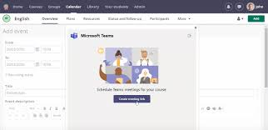

4. When it is time for their class to begin, they will see a Join Now button either at the bottom Posts Tab when their teacher begins the call.

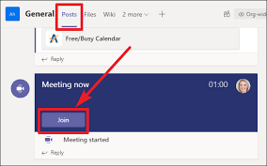

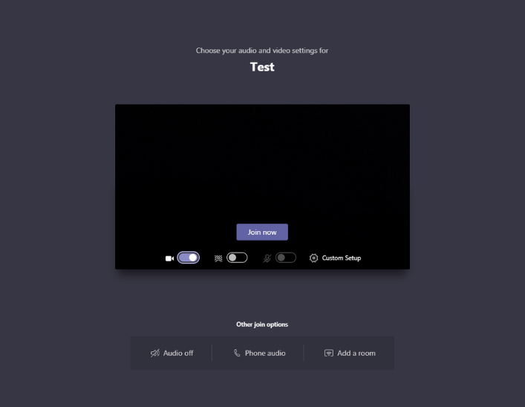5. Students will select that Join Now button, and they will then see their teacher and other students

Sincerely,



Mr. Mark Ametrano

